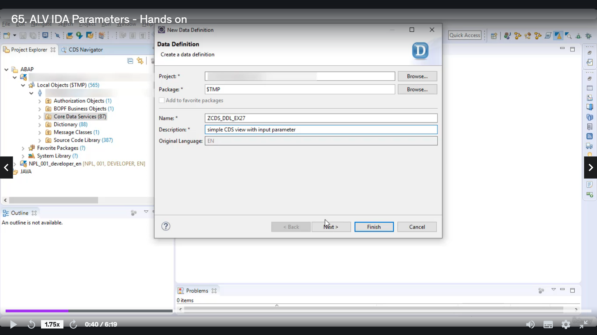

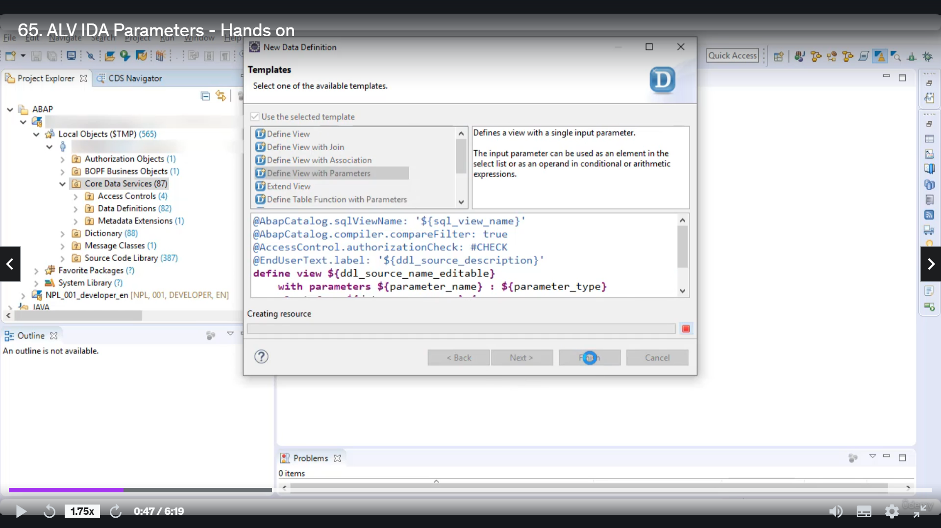

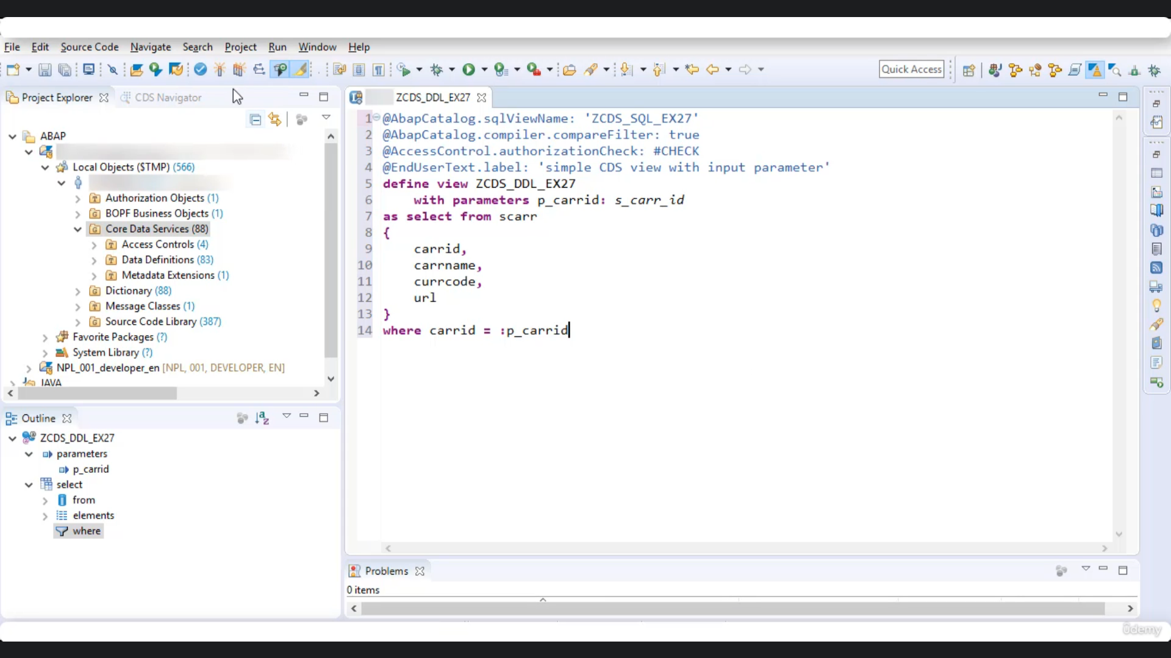

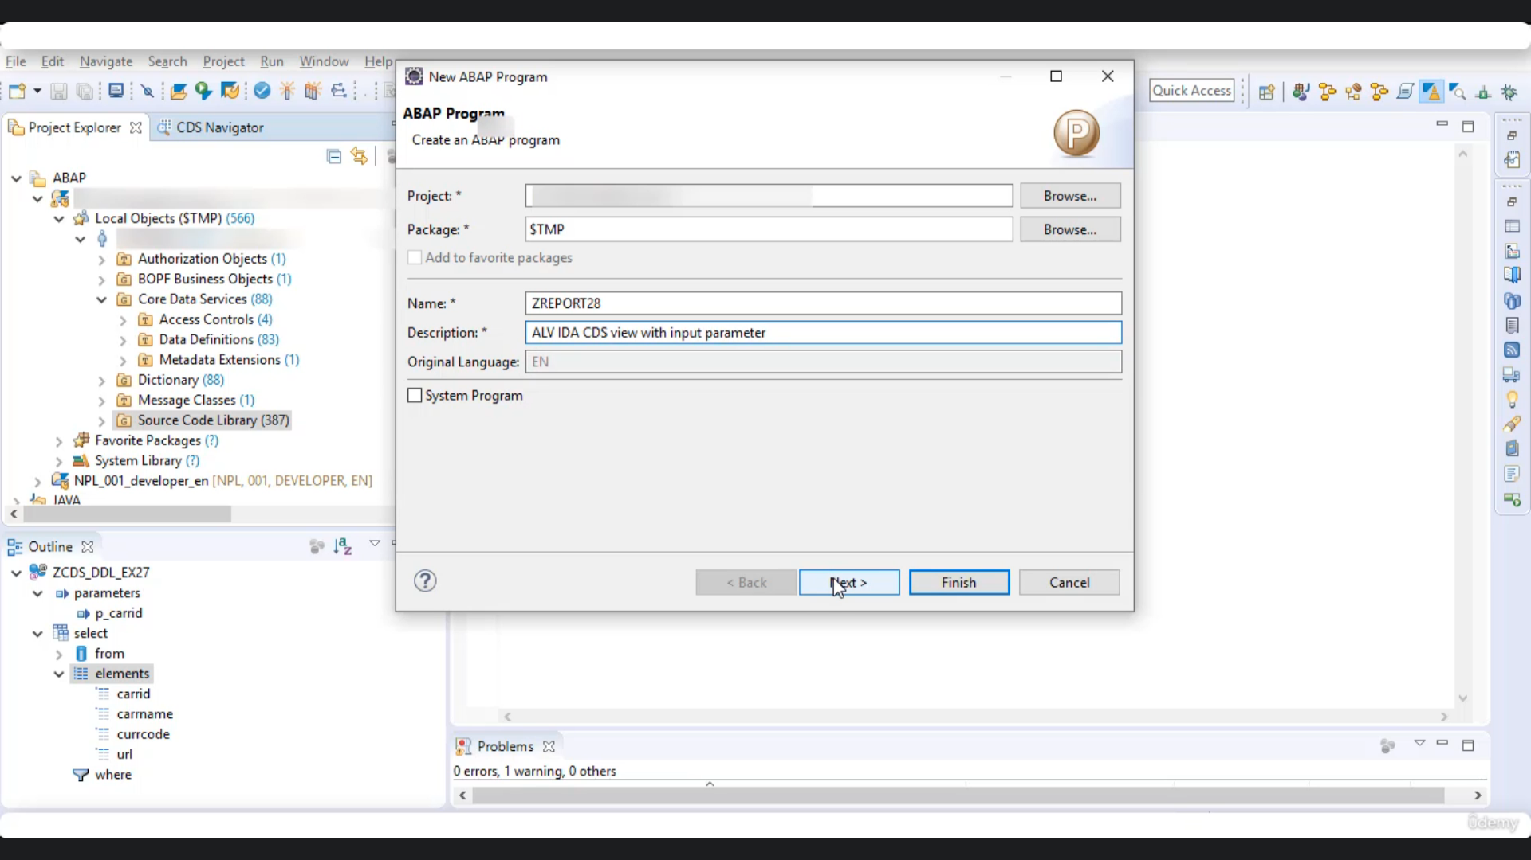

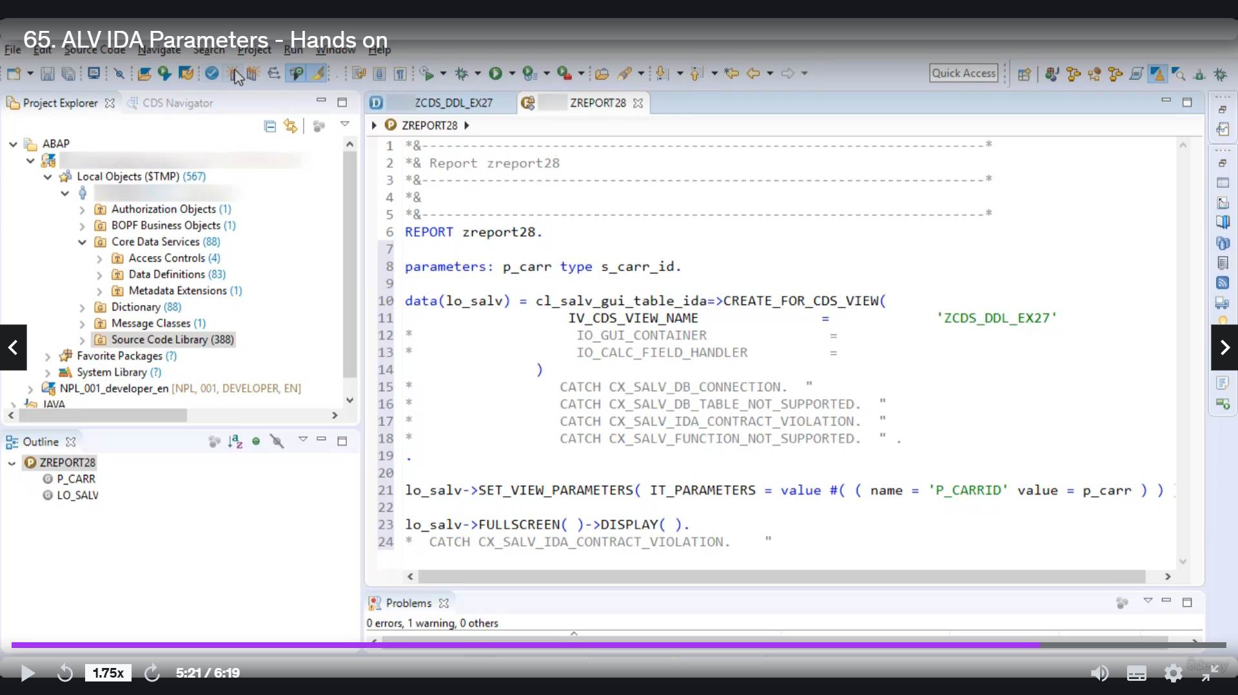

Knoedler screaton, Ababinili is filled with input barometer's, then we will create a vegetable program

and in that program we will see how we can pass parameter from a program to the input parameter of absolutist

view in Albania.

So let's start.

So let's first create a website view.

With no serious, detailed example, 27 and let's give a description as simple as it is, we with input

parameter.

Yarraville used template defense will be the barometer.

Now, let's quickly do the basic settings.

Let's say I want to read content from God

and I want to use Foo's Gennady Ghanim currency.

Good.

And you added.

Now, let's say I want to filter the onset of these absolutist view based on value value-based to fill

Garrity for that purpose, I will use parameter limits be carried and it is of type and some this could

get on the security.

And based on this parameter, I will put one filter condition where clarity equals to be underscored.

Garraty.

And that's it.

So let's quickly agree with this one.

OK, so now let's create whenever people program.

Let's give it a name, as did report 28.

No, let's give it description at Elvie ideas LDV with input parameter.

Now, in this report program, since we are to pass value to this input parameter of Gizzi, this Dujail

example 27, I will take that value input from user.

So for that purpose, I will to you parameters beyond the scorecard of time is underscored Garatti.

Now, I will go to my third grade, first issue of class is a regrettable idea

for students who know who you are to pass the name of our creative city to the name of all credits.

This is a serious, detailed example, 27.

OK, then.

Now, since we want to Barthwell.

From this perimeter, we get to input perimeter of our creative studios will be ready for that purpose

to use your.

Meter safety barometer and here you are to pass value to this metal with nimble loopier, so for that

purpose I will read.

Name here, you have to give the name of Syria's war barometer be underscored correctly and then you

to pass value that is presenting, but it would appear in the squad car now using this method said to

be a barometer.

We are passing value from our purple program to input parameter of probabilities through.

Then you have to simply Google to make their full screen.

And then Twitter display.

And.

So there is no better than I would like to this one.

And Lidstrom.

Now, let's put some value to this bigger parameter, because I want to possibly as a then execute.

OK, so here they are from what I've proposed program.

Let's test it for some other value.

I will pass Abe again to execute, and yes, it's working perfectly fine.

So this is how you can use idea to pass value from a reputable program to the input parameter of Abib.

Studious view.

Thank you for watching.

We you have a nice day.